## ECB tools

* APP
  + CBPP3: covered bond purchase program (2014 Oct)
    - 10%
  + ABS purchase programme (ABSPP, 2014 Nov)
    - 1%
  + Public sector purchase programme (PSPP, 2015 Mar)
    - 82% of net total purchase
  + Corporate sector purchase program (CSPP, 2016 Jun)
    - 7%
  + the size of APP is currently kept stable by reinvesting principal payments from maturing securities.
  + Clear and observable monthly APP targets were defined. The avg monthly APP target was decomposed to monthly guidance per programme.

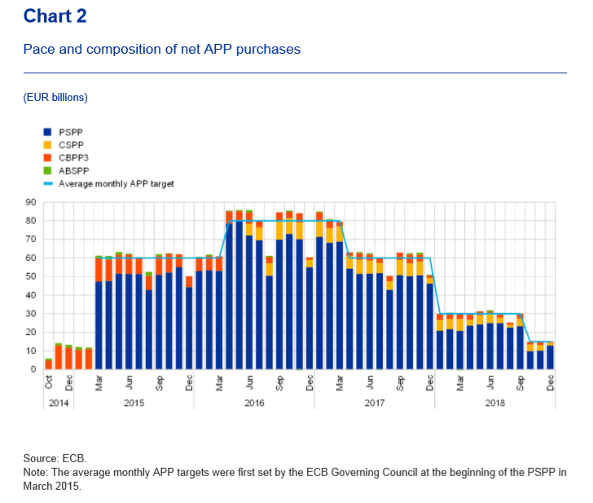

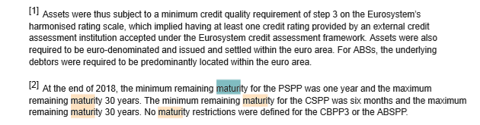

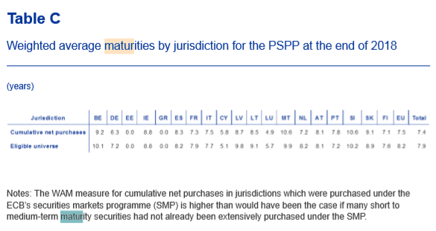

* Neg interest rate
* Forward guidance
* TLTROs (targeted long term refinancing operations)

## Understanding Fed

Target:

* To understand how to read the federal reserve website
* To understand the economic meaning of the federal reserve website tables
* To understand the terminologies

1. H3 tables: <https://www.federalreserve.gov/releases/h3/current/default.htm>
   1. Table 1:
      1. Reserve balance required (requirement, top band, bottom band)
      2. Reserve maintained (to satisfy the requirement, exceed)
         1. The requirement dropped to 0 on Mar 2020
   2. Table 2
      1. Reserves + vault cash(库存现金)=total balance maintained
      2. Total balance maintained + currency in circulation = total monetary base
   3. Reserve 定义: 银行没有放出去的款。等于库存现金+银行在央行的账户存款。Reserve + available 贷款资金 = 总资金。所以reserve = unavailable 贷款的资金
2. Senior financial officer survey <https://www.federalreserve.gov/data/sfos/feb-2020-senior-financial-officer-survey.htm>
   1. Quarter survey:
      1. Fed has increased the size of the fed balance sheet and the amount of the reserves in the banking system. **Reserve management** activity has changed
      2. 3 indicators they care:
         1. Lowest level of reserve balances they would be comfortable
         2. Level of HQLA(high quality liquid asset) they want to hold- 市场认为要求15bps 的收益
         3. Fed 似乎认为市场最看重的risk free rate是IOER(interest on excess reserves)
3. Senior loan officer opinion survey on bank lending practices.
   1. In 2020 Apr, significant number of banks have tightened their criteria to make loans to firms
   2. Also tightened the standards to make loans to household
4. Large commercial banks
5. Commercial paper rates and outstanding summary
   1. Commercial paper vs treasury bills:
      1. T-bills: 4 weeks to 1 year, short term US debt backed by the government; pay interest only at maturity.
      2. T- notes: mature 2-10 years, bi-annual interest rate
      3. T-bonds: 30 years or more, offer investors bi-annually interest payment
      4. TIPS: pay interest bi-annually
      5. Commercial paper has higher default risk. Thus higher return.
         1. Total outstanding: financial: 600bn, nonfinancial: 300bn
         2. Yield: 90d: about 50 bps.
6. Finance companies (财务公司)
   * 1. 应收账款total outstanding: 1300bn
        1. Consumer: 730 bn
        2. Real estate: 100 bn
        3. Business: 400bn
7. New security issues:
   1. state and local government:
      1. All issues, new and refunding: par amount on long term issues.
         1. Type: general obligation: secured by tax; revenue: secured by specific stream of revenues.
         2. Total 29.5 Bn dollars in Apr 2020; 434 bn dollars in 2019 whole year.
   2. US corp(exclude government and agency bonds):
      1. Financial:
         1. Bonds: maturing more than 1 year
         2. 2020 Apr: 71 billion bonds, 5 billion stocks
      2. Non-financial:
         1. 2020 Apr: 240 bn bonds; 7 bn stocks
      3. Technical:
         1. Financial issue includes ABS
         2. Medium term notes included in the issuance numbers.
            1. MTNs: 类似于信用卡，相当于带有option的债券
8. Senior credit officer opinion on dealer financing terms (not so important)\
9. H10: exchange rates
10. US reserves:
    1. Gold: unchanged over sometime
    2. SPR
    3. IMF
    4. Foreign
11. TIC data
12. Consumer credit: revolving vs non-revolving:
    1. Revolving: credit card: 1000 billion
    2. Non-revolving: student loans and auto loans： 3000 billion
13. Household debt service as % of personal income:
    1. Mortgage: 4; consumer: 6; total: 10
14. Mortgage debt outstanding:
    1. All sector: 16140 billion
    2. 1-4 family:
    3. Multi family residences
    4. Nonfarm, nonresidential
    5. Farm
    6. Holder category:
       1. Depository institutions
       2. Life insurance companies
       3. Fed related agencies
          1. Ginni mac
          2. Frennie mac
15. Survey of household economic decision making:
    1. Annual report?
16. Industrial production and capacity utilization
    1. 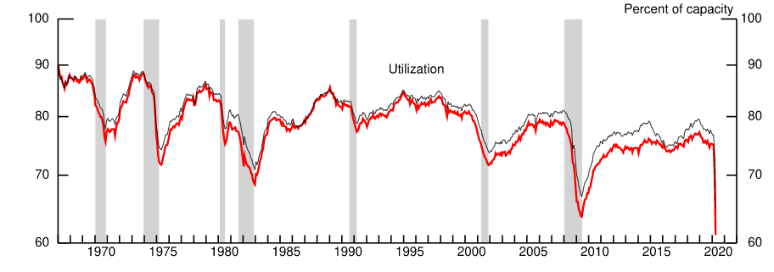
17. Factors affecting reserve balances (4.1)
    1. Reserve balances of depository institutions
       1. Reserve fund的定义：存款机构为了防止流动性问题，而没有带出去的款项。通常是流动性非常好的资产。(正项: 7000 bn， 负项：400bn， 净： 300bn)
       2. 正项 ：
          1. US treasuries, agencies, MBS (6000 bn)
          2. Unamortised premiums on securities held outright(300 bn): 未摊销溢价
          3. Repurchase agreement: 180 bn
          4. Loans: 100bn
          5. Commercial paper: 12bn
          6. Central bank liquidity swap (foreign currency assets)
          7. Gold stock: 11 bn
       3. 负项：
          1. 流通货币：2000bn
          2. Deposit with fed reserve banks, other than reserve balance (1500 bn) 这是什么？？？
    2. **有用：Maturity Distribution of Securities, Loans, and Selected Other Assets and Liabilities。这里面记录所有fed的holding 资产的久期情况。其中reverse repurchase agreement属于fed的liability. 其他都是资产。 这跟下面的表格： Consolidated Statement of Condition of All Federal Reserve Banks能够相对应上：、**
       1. **UST: 4150 bn**
       2. **Fed agency debt: 2 bn**
       3. **MBS: 1800bn**
       4. **Commercial paper: 4 bn**
       5. **MNT: 1.2 bn**
       6. **Repurchase: 167bn**
       7. **CB liquidity swap: 444bn**
       8. **Technical question: what is the net portfolio holdings of commercial paper facilities, in specific what does “net portfolio holdings” mean（可能的答案：**The FRBNY is the managing member of CPFF II LLC. Consistent with generally accepted accounting principles, the assets and liabilities of the CPFF II LLC have been consolidated with the assets and liabilities of the FRBNY in the preparation of the statements of condition. As a consequence of the consolidation, the loan from the FRBNY to CPFF II LLC is eliminated, the net assets of the CPFF II LLC appear as assets above, and the liabilities of the CPFF II LLC to entities other than the FRBNY, including those with recourse only to the portfolio holdings of the CPFF II LLC are included in other liabilities in this table. Net portfolio holdings of the LLC Includes assets purchased pursuant to terms of the credit facility and amounts related to Treasury contributions to the facility. <https://www.federalreserve.gov/monetarypolicy/consolidated_statement_pa.htm>**）。所谓的net应该是NYFED的一些计算方法导致的不能将asset和liability分开，统称为asset。实际计算的时候应该以这个consolidated为准。**
       9. **计算weighted average holdings的方法：第一，计算weighted average duration for that item, 再转换成10年，得到一个scale factor.用这个scale factor乘以consolidated里面的数值。**
18. SOMA: <https://www.newyorkfed.org/markets/soma/sysopen_accholdings.html>

## USA mortgage market data (FT: the ultimate check is to compare with flow of fund data):

* + - 1. MBA: covers 75% residential mortgage
      2. FRB H8 form: domestic+foreign depository institutions; covers both residential and commercial
         1. Has break points on dates: 1988-12-29, 2006-9-28, 2008,9,25
      3. Mortgage debt outstanding (low freq, covers all holders MBS etc)